## 算法目标

In this paper, we (1) introduce practical solvers that simultaneously compute either a fundamental matrix or a homography and time shift between image sequences

## 算法输出

We solve for fundamental matrix or homography together with temporal offset of image sequences.

## 算法优点

1. Our methods need only moving image point trajectories, which are easy to track.

1. Unlike in [21, 20], we use a small (minimal) numbers of correspondences and we therefore are robust to outliers when combined with RANSAC robust estimation.

## 测试结果：算法适用场景

We evaluated our approach on a wide range of scenes and demonstrated its capability of synchronizing various kinds of real camera setups, such as driving cars, surveillance cameras, or sports match recordings with no other information than image data.（没有其他信息）

## 测试结果：算法适用时间偏移范围

We demonstrate that our solvers are able to synchronize small time shifts of fractions of a second as well as large time shifts of tens of seconds.

## 核心数学论证

In general, there is no correspondence between the si and s’j samples, i.e., for i = j, si and s’j do not represent the projections of the same 3D point. There are two main sources of desynchronization in video streams.

### 不同步的原因

1. The first one is the different recording starts or camera shutters triggering independently leading to a constant time shift.
2. The second source are different frame rates or imprecise clocks leading to different time scales.

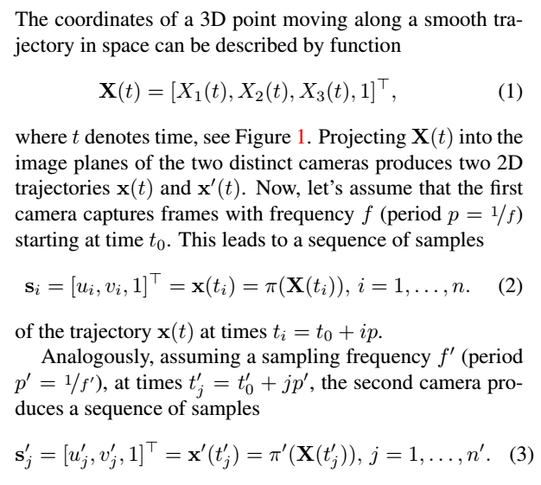

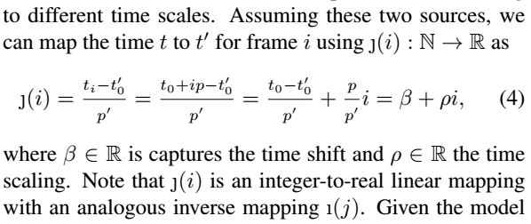



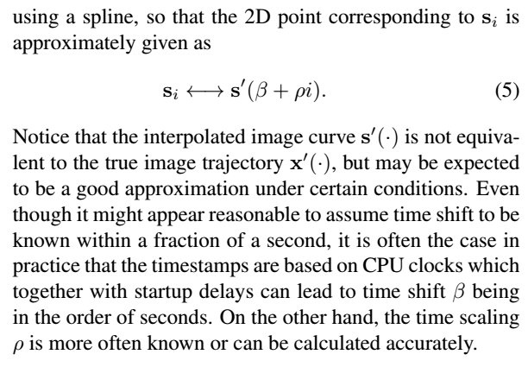

### 结合实际谈

Even though it might appear reasonable to assume time shift to be known within a fraction of a second, it is often the case in practice that the timestamps are based on CPU clocks which together with startup delays can lead to time shift β being in the order of seconds. On the other hand, the time scaling ρ is more often known or can be calculated accurately。

## 理论上解法

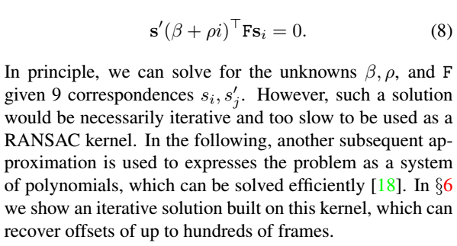

unknowns β, ρ, and F

given 9 correspondences si, s’j.

## 问题简化

### 简化前提

Let us assume that the relative framerate ρ is known.

### 泰勒展开

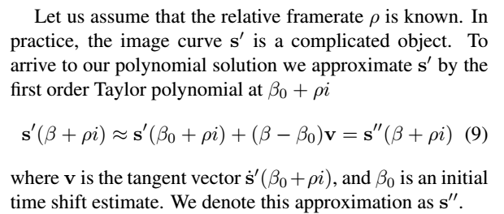



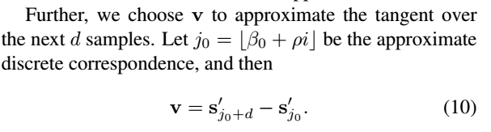

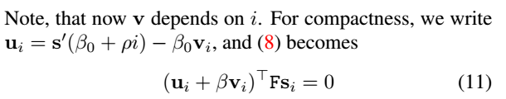

### 进一步简化

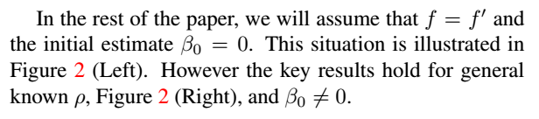

f指的是s’(β+ρi)

f指的是s’’(β+ρi) ,只是这样表示，s’’不要理解成s’的导数

注意说的figure 2 说明结果也适用于known ρ，β0≠0的情况

## 解决方法1（8个sample 点）理论epipolar geometry 模型

### 简化模型

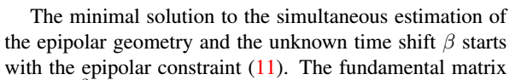

β不知道



### Input 需要

一个隐藏条件

Therefore, the minimal number of samples si and s’i necessary to solve this problem is eight.

## 解决方法2（9个sample点）理论epipolar geometry 模型

